Determination of nitrate in 2M KCl soil extracts by FIAstar 5000

1. Scope and field of application
This Application Note describes a method for determination of nitrate in soil extracts in the following range:

0.1-5 mg/l NO₃-N in the extract (40 μl loop), linear calibration.*

*The range may be extended up to 10 ppm by using a smaller injection loop, see Appendix 1.
2. Principle of the method
Nitrate in the soil sample is extracted by 2M KCl. The suspension is centrifuged and filtered and can after this treatment be introduced in a flow injection system. The chemical principle for determination of nitrate is reduction to nitrite in a cadmium reductor. See AN 5201 for details. The described method gives the sum of nitrite and nitrate originally present in the extract. However, the original concentration of nitrite is in most cases negligible in comparison with the nitrate concentration.
3. Reagents
Before using any chemicals refer to adequate manuals or safety data sheets approved by your local authorities. If not stated otherwise, only reagents of recognised analytical grade and water according to grade 1 of ISO 3696 shall be used.

3.1 Sulphanilamide (4-aminobenzenesulfonamide), C₆H₈N₂O₂S
3.2 N-(1-naphtyl)-Ethylene Diamine Dihydrochloride , C₁₂H₁₄N₂ x 2 HCl
3.3 Hydrochloric acid; HCl ω=37%
3.4 Sodium Nitrite, NaNO₂, dried to constant mass at 150 °C
3.5 Sodium Nitrate, NaNO₃, dried to constant mass at 105 °C
3.6 Ammonium Chloride, NH₄Cl
3.7 Ammonia, NH₄OH
3.8 Potassium Chloride, KCl
3.9 2M Potassium chloride, KCl
In a suitable container, dissolve Potassium chloride in water.
For preparation of this solution, see table

Volume | KCl
1 l | 149.1 g
5 l | 745.5 g
10 l | 1491 g
20 l | 2982 g

3.10 Carrier solution, 2M KCl
See 3.9
3.11 Ammonium Chloride buffer pH 8.5, reagent 
Dissolve 85 g Ammonium Chloride, NH₄Cl in 500 ml of distilled water. Allow the solution to reach room temperature. Add Ammonia, NH₄OH (about 12 ml) to reach a pH of 8.5. Mix and dilute to 1000 ml with distilled water.
3.12 Sulphanilamide reagent 
In a volumetric flask of nominal capacity 500 ml, dissolve 5g Sulphanilamide in 250 ml distilled water. Add 25 ml concentrated Hydrochloric acid and mix carefully. Dilute to volume with distilled water. Transfer the content of the flask to the reagent bottle labelled .
This reagent is stable for several months.
Note! For the preparation of this reagent 50 ml of Phosphoric acid may be used instead of Hydrochloric acid
3.13 NED reagent 
In a volumetric flask of nominal capacity 500 ml, dissolve 0.5g N-(1-naphtyl)-Ethylene Diamine Dihydrochloride in approximately 250 ml of distilled water. Make up to volume with distilled water. Transfer the content to the reagent bottle labelled .
This solution should be freshly prepared every week.
3.14 Stock standard solution, 1000 mg/l NO₃-N
In a volumetric flask of nominal capacity 1000 ml, dissolve 6.068 g Sodium Nitrate and dilute to volume with distilled water.
The stock standard is stable for at least 3 months.
3.15 Interim stock standard 20 mg/l NO₃-N
Pipette 10 ml of the stock standard solution into a 500 ml volumetric flask and dilute to volume with 2 M KCl.
This solution should be prepared fresh daily.
3.16 Calibrating solutions
The calibrating solutions are prepared by diluting the solution described in 3.15 with 2 M KCl. At least five calibration standards per working range are recommended

Working range 0.1-5 mg/l NO₃-N

NO₃-N concentration  mg/l | Volume interim standard (3.13)  Ml | Final volume  ml
0 | - | 100
0.1 | 0.5 | 100
0.5 | 2.5 | 100
1 | 5 | 100
2 | 10 | 100
5 | 25 | 100

The calibrating solutions should be prepared fresh daily.
3.17 Solution 1 mg/l NO₂ –N for checking the reduction efficiency
In a volumetric flask of nominal capacity 1000 ml, dissolve 0.4928 g Sodium Nitrite, NaNO₂ in water and dilute to volume. This stock solution corresponds to 100mg/l as NO₂-N.
In a 100ml volumetric flask, pipette 1ml of the stock solution and dilute to volume with 2 M KCl.
The 1mg/l solution is unstable and should be prepared daily.

4. Apparatus
Usual laboratory apparatus and

4.1 FIAstar 5000 Analyzer unit.
4.2 Method cassette NO₂/NO₃ +interference filters 540 nm and 720 nm.
4.3 5027 Sampler (optional)
4.4 Prepacked reduction columns, part no. 5000 3139
4.5 Volumetric flasks, of nominal capacity 100 ml, 500 ml and 1000 ml.
4.6 Pipettes of nominal capacity 0.5-25 ml
4.7 pH electrode
4.8 Shaking machine
4.9 Centrifuge
4.10 Filter paper, type Whatman No. 1 or Munktell No. 4.

5. Procedure
5.1 Sampling and sample preparation
Weigh in 10 g air-dried soil into a 100 ml flask. Add 50 ml of 2M KCl and shake for one hour. Transfer the suspension to a centrifuge tube and centrifuge for 5 min, and/or filter the supernatant solution through Whatman No. 1 or Munktell No. 4 washed filter paper.
5.2 Starting up the system
- Power on all FIA modules and (if used) the 5027 Sampler.
- Verify that the correct method cassette, corresponding detector filters and loops are installed.
- Start the pump/s and pump distilled water through each FIA and check the flow.
- Power on PC, launch SoFIA and load the method.
- Observe water baseline(s) using the Inspect/Read baseline menu in SoFIA. (see 5.9 Remark 1)
  - SD (M-R) < 0.1 mAU
- Start pumping the reagents. The method selector should be in the NO₂ position (see fig.2).
- When the system is filled with liquid turn the method selector to NO₂+NO₃ position (see fig.1).
- Pump until all the air in the by-pass tube is gone.
- Stop the pumps, remove the by-pass tube and install the Cadmium reductor.
- Restart the pump and allow the reagent flow to stabilize.
- Observe reagent baseline using the Inspect/Read baseline menu in SoFIA. (see 5.9 Remark 1)
  - SD (M-R) < 0.2 mAU
- Load the Sampler with the samples and create a Sample List in SoFIA.
- Load the calibration standard/s on the Sampler.
- Perform a few Test Injections (Inspect/Test Injection) using one of the standards to verify that the system is equilibrated.
  - As guideline, repetitive injections should not differ more than 2% on a mAU or ppm basis.
- Check the efficiency of the reductor by using the Inspect/Test Reduction efficiency in SoFIA and follow the instructions.(See 5.4.1 for more details)
- Make a calibration/check calibration.
- Start the Sample List.
5.3 Closing down
Note! Since the method involves strongly concentrated liquids the closing down procedure is especially important to guarantee a good performance of the system. The below procedure will first rinse out the strong KCl solution from the system and the reductor. Next step is to bypass the reductor and rinse the whole system with water. In this way, the buffer solution stays in the reductor as storage liquid.

- Stop the pump. Replace the Carrier solution (KCl) with distilled water.
- Start the pump again, and pump for about 5 minutes. This will wash out the KCl solution from the Cadmium column.
- Next, switch over to the NO₂ position (see figure 2) and replace all the other reagents with distilled water.
- Pump water through the system for a few minutes. Stop the pump. Remove the cadmium reductor and reinstall the teflon by-pass tube. Restart the pump. Switch over to NO2 + NO3 position (see figure 1).
- Make sure the sample wash bottle is filled wih distilled water. If the system is used without a sampler, put the sample inlet tube in a beaker with distilled water.
- Start the Rinse cycle in the software.
- When the Rinse cycle is completed, disconnect all pump tubes and pump air through the units to remove the remaining water.
- Release the pump tube holders.
- Turn the analyzer off.

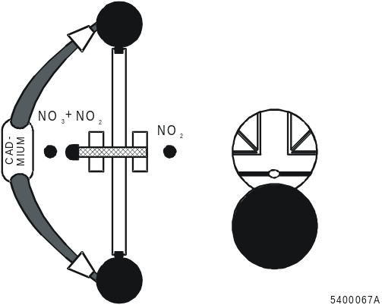 | 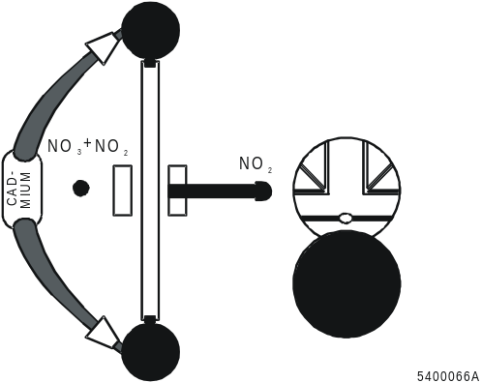
Figure 1. NO₂/NO₃ position | Figure 2. NO₂ position

5.4 Cadmium reductor
WARNING! Cadmium is toxic. Particles cannot be released from the reductor unless broken. Handle the reductor with care.
5.4.1 Checking the efficiency of the reductor
The efficiency of the reductor must be checked regularly. Use the Inspect/Test Reduction efficiency in the software and follow the instructions. Do as follows:
- Inject a 1 mg/l NO₃-N solution over the cadmium reductor.
- Inject a 1 mg/l NO₂-N solution over the cadmium reductor. The absorbance value of the NO₃ solution should be 85-100 % of the NO₂ solution. If efficiency is less, try activation as in section 5.4.2
5.4.2 Reductor activation
To activate the reductor for the first time or after a long period of without use make a few injections of 1M HCl followed by 200 ppm NO₃-N. Then make a few injections of a standard until a stable result is obtained.
5.4.3 Handling and storage of the reductor
Avoid pumping water through the reductor as this will decrease its lifetime. Always store the reductor filled with the Ammonium Chloride buffer. This is achieved by following the above Closing down procedure.
Seal the ends with the steel stoppers provided. For longer storage, the Cadmium-reductor must be kept in an air-tight plastic bag/container with a small amount of water to prevent it from drying out.
5.5 Interferences
Coloured constituents in the soil, which absorb in the photometric range used, will interfere. It is important that the KCl concentration in the extract is kept fairly constant, otherwise matrix effects may appear. The variation of the KCl concentration originates from the variation in water content in the soil samples.
5.6 Results
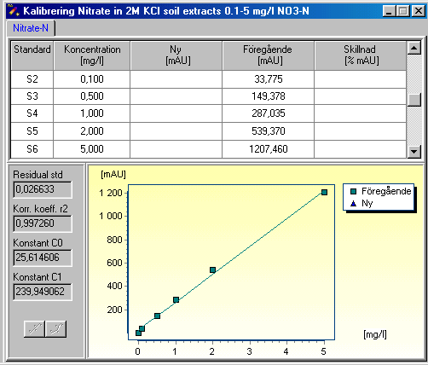
Typical calibration data: Range 0.1-5 mg/l

Note! Variations may occur due to temperature variations, pump tube conditions, reagent purity etc.
5.7 Calculation of results:
The results can be expressed as mg NO₃-N/kg sample using the following formula:

w = (C *V)/W

Where
w = mg NO₃-N /kg soil
C = concentration nitrate as mg/l NO₃-N
V = volume of the extract in ml
W = weight of the soil sample in g
5.8 Performance data
Repeatability (RSD) is about 0.6 % for a 2 mg/l NO₃-N standard.
5.9 Remarks
- The standard deviation on the baseline on both water and reagents gives an indication of system flow and function. A high standard deviation (SD) can be caused by :
  - poor pump tubes/flow
  - too much dissolved air in the reagents
  - undissolved matter in the reagents
Refer to the User manual for troubleshooting high standard deviations.
- The range may be extended up to 10 mg/l by reducing the injection loop volume to 20uL, see Appendix 1.

6. Bibliography
- ISO 13395. Water quality-Determination of nitrite nitrogen and nitrate nitrogen and the sum of both by flow analysis (CFA and FIA) and spectrometric detection.
- K. Bendschneider and R. Robinson; J.Mar.Res 11 (1952) 87
- L. Anderson, Anal Chim Acta; 110 (1979) 123
- M.F. Gine´, H. Bergamin Filho, E.A.G. Zagetto, & B.F. Reis; Anal Chim Acta, 114 (1980) 19.
- Methods of Seawater Analysis, K. Grasshoff, Verlag Chemie 1976
- ISO 3696 Water for analytical laboratory use – Specification and test methods.
- ISO 8466 Water quality - Calibration and evaluation of analytical methods and estimation of performance characteristics
7. Revision History
Revision | Description of change | Date | Sign.
Rev. 1 | Initial revision | 2000-03-06 | KAx
Rev.2 | Added Figure 1 and 2 | 2001-12-13 | KAx
Rev. 3 | Closing down procedure – wash out KCl from reductor.  Extending range by using smaller loop. | 2006-11-16 | KAx
Rev. 4 | New template  Modified start up procecedure  Added preparation of solution for reduction efficiency test | 2008-04-14 | KAz

8. Method/cassette specification
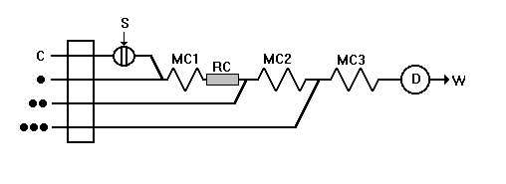
Flowscheme
Pump tube Code
C red/red
R1 () black/black
R2 () orange/white
R3 () orange/white
S grey/grey
Parameter settings
Wavelengths: M=540 nm, R=720 nm
Signal filtration: 1 s sliding mean
Injection volume: 40 μl *
Injection time: 20 s
Fill time: 40 s
Measuring time: 60 s
Sampler, cup duration time: 40 s
Sampler, wash duration time: 20 s
Pump speed: 40 rpm
Evaluation: Peak height
* The range may be extended up to 10 ppm by using a 20uL, see Appendix 1.

Cassette configuration

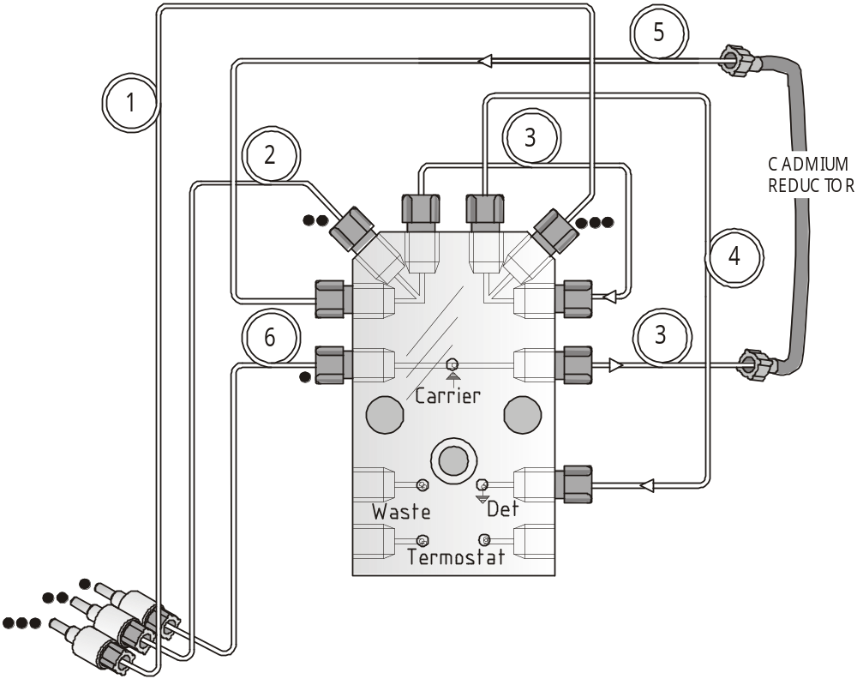

Pos Tube Length (cm)/ID (mm) Part No
1 Teflon tube 21/0.5 10009898*
2 Teflon tube 12/0.5 10009970*
3 Mixing coil 30/0.5 10010081*
4 Mixing coil 60/0.5 10010082*
5 Teflon tube 15/0.5 50003138*
6 Teflon tube 9/0.5 10009897*
*(Available in Teflon Tube set 10012352 or 10010207)
Teflon tube colour codes for cassette:
Connector ID (mm)
NOTE! The method cassettes are configured in both hardware and software. If other teflon tubes or pumptubes are used than those specified, it may lead to longer/shorter measuring times. In that case the software method needs to be modified.

White 0.35
Red 0.5
Green 0.7
APPENDIX 1
Installation of a 20µl Sample Loop:
- Open the valve panel.
- Locate the 2 transmission tubes (#3 & #6 see picture) leading the sample from the external loop to valve and back.
- Unscrew tubing #3 from the injection valve port
- Then unscrew tubing #6 from the valve panel, but leave it screwed in on the injection valve port.
- Now bend tubing #6 over and reconnect it on the freed port on the valve.
- Note: the external loop is not used, if desired remove it
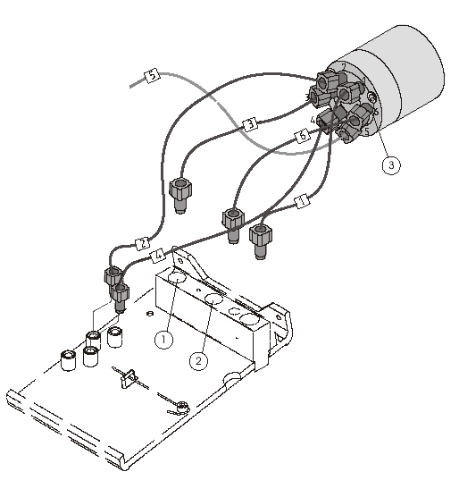

Dedicated Analytical Solutions
P/N No. AN5206 FOSS Analytical A/S Tel: +45 7010 3370
Issue No. 4 69 Slangerupgade Fax: +45 7010 3371
April 2008 DK-3400 Hilleroed E-mail: info@foss.dk
Company Reg.No. 7339 9815 Web: www.foss.dk

